CONTAINER BASED VIRUALIZATION SECURITY

VIVEK.V.SARKALE ,

UNIVERSITY OF TEXAS AT SAN ANONIO,SAN ANTONIO, TX, USA
DEPARTMENT OF COMPUTER SCIENCE AT UTSA , SA,TX,USA

ABSTRACT

// I’ll write abstract at the end //

INTRODUCTION

In recent years the term virtualization has become buzzword, virtualization technology means to create virtual version of a devices or resource ,such as server, storage device ,network or operating system where framework divides resources in one or more execution environments . Server virtualization are more popular virtualization technologies where physical server is partitioned into smaller virtual server- operating system virtualization as sub category of server virtualization allow user to run multiple operating system instances on host . Popular service providers like Amazon EC2 ,MyCloud, Microsoft Azure brought virtualization technology for user.
Virtualization technology solution mainly classified into two;
First is Hypervisor based virtualization and other is container based virtualization . Out of two ,container based virtualization provides lightweight and isolated environment .

Container based virtualization –Containerization allow multiple isolated user-space instances with separate filesystem look like complete isolated system .Every instance run as singe instance of operating system and has its own IP-address, network interface ,filesystem and unique process id. Positive side of containerization is host operating system has complete visibility to entities running on it. Fig[1] illustrates the general idea about container based virtualization where host kernel runs multiple virtual instances ,these virtual instances referred as Linux containers .Containers provide light weight form of virtual environment and has zero performance overhead ,better resource utilization and easy to create and destroy . Although,
Container based virtualization is blamed to be less secure.

This paper ,we analyze container based virtualization security ,we have organized deep study on potential threats to the containerization and alongside we have discuss Linux kernel internal features such as Namespaces ,C Groups and other supporting Linux security modules(LSM) like SELinux ,Apparmor , SECcomp and GRSec. This is a first academic research paper which focus on container based virtualization security and also come up with some attack resistant access control policy enforcement architecture.In this paper Section 3 provides detail information on containerization security background and threat model. In Section 4 we discuss about internal security features and Linux security modules (LSM) in detail.

Fig 1. Container Based Virtualization

3. BACKGROUND

Container based virtualization usually gets compare
with hypervisor based virtualization which is considered
to be more secured –In which any application running on guest operating system is only able approach guest OS
kernel ,If any malicious application running on guest can’t directly break down to host as it has to bypass guest kernel & Virtual Machine Manager which makes hypervisor based virtualization more secure. Other hand In container based virtualization , Light weight linux containers runs on container engine and very easily able to approach host kernel by malicious program running inside containers which actually create a possibility of host kernel exploitation and comprises security of whole system .Along side with Application Image security,Container security it is most important to provide security measures in order to secure host Kernel.
Here are some threats which faced by Container based virtualization.

3.1 POTENTIAL THREATS

Security is one of the major challenge when we are running
A service in virtual environment ,especially in the multi tenant Cloud system. Containerization is not an exception thus have several security issues. Our analysis consider various threats
, security issues and vulnerabilities in container based virtualization ,such as Linux kernel exploit , Leak to other
Container ,Container Engine Attack Surface , Fake System calls and other Issues.

3.1.1 Linux Kernel Exploit

Unlike hypervisor based virtualization running VM’s, the kernel is shared among all containers and host. Running malicious container may cause panic to kernel ,it can take down host typically damages whole system . In VMs, the situation is much better ,an attacking program would have to route an attack through both the VM kernel and the hypervisor before being able to touch the host kernel but this is not the case with containerization. Containers which demands extra privileges to run called as privileged containers where container UID 0(root privileges ) is mapped to host’s UID 0.
That indicates that root inside container is also root outside container (on Host),In that case host is really on high risk ,we need worry about potential privilege escalation attacks –where user gains elevated privileges such as those of root users. Container break outs are unlikely but always possible in certain cases . Mechanisms like Mandatory Access Control(MAC) typically prevent host from accidental damages like reconfiguration of host hardware , host kernel or filesystem access but still some vulnerable environment exists which will let such container escape and get full root privileges on host .
Un-privileged containers are safe by design . Any container UID 0 (root) inside container is actually non zero UID (non-root) outside container but still general security issues such as container escape , resource abuse are exist and considered as threat to the system

3.2 Container Breakouts

we know that one container doesn’t get access to socket or interfaces of other container but of course if host system is already set up accordingly then containers communicate with each other with using network interface. N number of containers run parallel ,in worst case if attacker take over any of the container should not be able to gain access to other honest containers and host because most of the times by default users are not correctly namespaced

3.3 Container Engine Attack Surface

While running LXC on container engine, it require to have root privileges therefore only trusted users should be allowed to control our container engine .

//Still 2 more points to come : Quite skeptical about it.

3.4 Other Security Issue

Several other security threats are commonly addressed in containerization ,such as poison images , fake system calls and other attacks –such as Daniel of Service . How one can know that the images you are using are safe, There possibility that that attacker can trick us into running his image hence our data and host at high risk. It is necessary to ensure that images we running are up-to-date and does not contain software with vulnerabilities .

//Dos
//fake system calls

4. CONTAINERIZATION SECURITY

4.1 INTERNAL SECURITY FEATURES

4.1.1 linux namespaces

Linux namespaces mainly provide form of isolation which
Creates isolated environment for every running container on host. Process running within container cannot have visibility to processes which is run by other containers, or even less affect, processes running in another container ,or in the host system[].Single underlying host runs n number of Linux containers and with the help of namespaces containers are assigned to its own independent runtime environment. Each get its ownPID-Process isolation, Network namespaces,Mount Namespaces-Filesystem isolation & IPC Namespaces – Inert process communication isolation which mainly contribute to container security.

PID Namespaces -Process Isolation
PID namespaces isolates the process ID number space , simply process in different PID namespaces can have same PID[]. PID namespaces ensures runtime process isolation ,Containerization ensure process isolation by limiting their permission and visibility to process running in the other container and the host , also allow container to suspend and resume set of processes in the container ,live migration of container to other host while process inside container stays with same PID. Use of PID namespaces requires a kernel that is configured with CONFIG_PID_NS option [1].

Network Namespaces –Network Interface Isolation
Network namespaces provides independent network stacks to every instance and isolate system resources such as network devices ,port numbers(sockets ),firewalls ,IP routing table. This allow container to establish communication between each other or host by using virtual network bridge but network traffic of one container can not be manipulated. Use of network namespaces requires a kernel that is configured with the CONFIG_NET_NS option [2].

IPC –Inter Process Communication Isolation
IPC namespaces gives a container its own inter process communication resources ,also exhibit set of objects for data exchange between among processes. Each IPC namespace has its own system v IPC objects [3] and POSIX massage queue file system . One process in certain IPC namespace can not read and write resources in other IPC namespace-simply member of one IPC namespace have no visibility to process in other IPC namespace.

Mount Namespaces-File System Isolation
Every running container gets associated with its own filesystem , In order to protect container and host’s file system from unaccredited access mount namespaces provide complete filesystem isolation. The processes in different mount namespaces can have different view of the file system and mount events inside container are restricted within particular container. Mount namespaces keeps compromised container away from making threats by removing containers write permission to filesystem and also restrict from remounting of filesystem within container .

4.1.2 c groups
C Groups turns to be a key component in containerization as it limits and control resource ,they provide limiting and accounting as wells as ensure that every instance gets its fair share of memory ,CPU and I/O devices. C groups usually prevents system from getting down by restricting exhaustive usage and also reject privileges to create a new device node which guarantees better security in the system ,they are essential to fend off some denial-of-service attacks. C groups are crucial on multi-tenant platforms, such as public and private Paas, to ensure consistent uptime to guarantee a consistent uptime(andperformance) when some application start to misbehave.

4.2 LINUX KERNEL SECURITY MODELS

4.2.1 LINUX CAPABILITIES
Unix system contains two type of processes :Privileged processes with user Id 0 or root user , Unprivileged processes with nonzero UID or non-root [4] . Privileged processes don’t required to pass all kernel permission checks although unprivileged processes undergoes through full permission checking. Root privileges are further divided into different forms and named as Linux Capabilities. Linux kernel is central authority to enable or disable capabilities of the root. Configuration and assignment of large number of capabilities to any container creates possibility of potential threat to the underlying host . As security principle states ‘less is more secure’ it is always recommended to not provide capabilities other than necessary.
List of major capabilities implemented on Linux[5]

//Here comes Useful Capabilities list: I’m validating them!

4.2.2 SELinux
Security Enhanced Linux(SELinux)[]is security architecture built into Linux kernel which provides flexible mandatory access control and running user process has access permission to files ,processes and sockets under DAC[]. Linux kernel running with MAC[] ensures protection to host from malicious applications running on it. SElinux defines access policies for every user ,application ,process and files. It’s a system administrator who decide to implement this policies to the server, policies can be strict or as lenient as required. SELinux policies are categorized into three: Type enforcement policies ,Multi-level security enforcement policies and Multi category security enforcement policies .MAC works by assigning labels to each file system object ,System administrator refers label to write a policies in order to control access between subject and object. In DAC user has complete control over programs and objects that it owns ,In such cases attacker gets access to all objects if user is compromised but SELinux allows Linux kernel to manage access control which enhance security level to high.

Fig[2] states SELinux decision making process ,when a process attempts to access any labeled object ,the policy enforcement server refer an access vector cache(AVC) ,where access control permission policies are defined .If access decision cannot be taken based on policies in AVC then security server handles access request ,which performs complete security check and convey granted or denied access message.

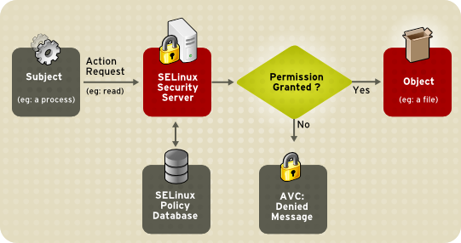 Figure 2. SELinux Decision Process

4.2.3 APPARMOR
Apparmor[] is mandatory access control (or MAC) system ,uses Linux Security Modules(LSM ) enhancement to restrict processes to certain resources . Apparmor load profiles in every program when system starts and decides which files and resources program can access. Apparmor is installed by default and has two types of profile modes, enforcement and complain. Enforcement mode enforce policies on program and also reports policy violation attempt if any. Complain mode don’t enforce any policies but it keeps log of policy violation attempts
Apparmor security model prevent application from turning evil , Even if application running inside container is compromised enforcement profile mode restrict process and prevent from accessing important filesystem on host.
// I’m trying to pull code or example here .

4.2.4 SECCOMP
SECCOMP-Secure Computing method[] is Linux kernel feature , mainly used to restrict action within container. SECCOMP provides system call filtering and provides means for a process to specify a filter for incoming system calls. Filter is expressed as Berkeley packet filter(BPF) program with the socket filters .This allows filtering of system calls using filter program language with some history and formal data sets . On Linux SECCOMP is enabled via system call using PR_SET_SECCOMP argument.

INSPECTION
Container based virtualization security mainly rely on Linux internal security features and Other Linux Security Modules. Namespaces , C Groups contributes to security by providing process isolation and resource limiting .Other Linux Security Modules(LSM) like SElinux and Apparmor security architectures make use of mandatory access control (MAC) in order to protect Linux kernel from external threats but they enforce access control policies on process at the lower level of system. Fig[3] illustrates the current security architecture which mainly focused on Linux kernel protection from malicious attacker.
Fig .3 Container based Security architecture
We have no access control policy enforcement and runtime activity monitoring which can co-assist with container engine in order to provide some extra security measures at top. We propose security architecture that enhance security level by enforcing improved access control policies and runtime security checks , detection can be done continuously .

5. MOST PRIVILEGED CONTAINER
We propose security architecture where two additional security features have been added to existing model which ensures high level security .As we inspect we have no access control enforcement and monitoring system at the top level of architecture. We introduce two important things: (1) Container Security Profile (2)Most privilege container –with Access control policies & behavior monitoring.
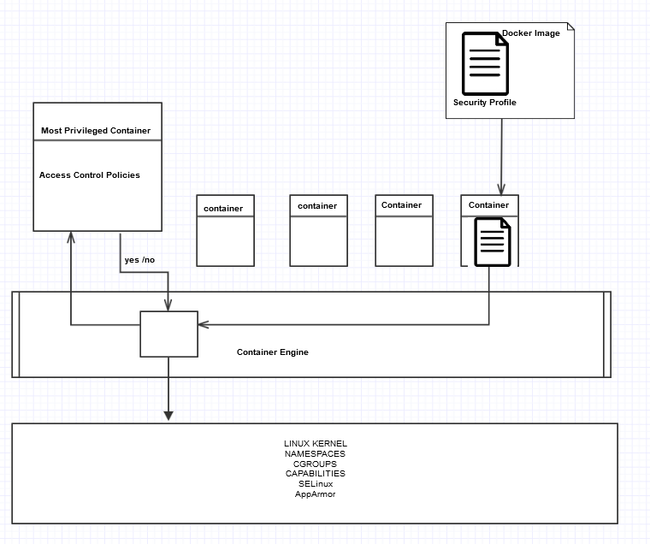

Fig .4 MPC with RBAC
Container Security profile: It is producer who should provide unified security profile for every container, profile should remain within container wherever it runs. Profile should include information such as, what resources that container can access ,what are the privilege that container can have on host . In detail ,container profile should be enclosed with information that describes minimum resources requirements , runtime behavior and extra privileges if it requires . Containers security profiles are used as unique identifier .
Container security profile assist container engine in order to ensure fine grained control over kind of resources that container access . Container Engine doesn’t worry about access control and it is hard to have access control overload on container engine. We propose completely separate authority in order to provide access control over every process , that system is nothing but container and we named it as most privileged container(MPC) which runs all the time on container engine. We’ll discuss about MPC in next part of this section.

Most Privilege Container:
Proposed Most privilege container running up all the time on container engine , Access control policies are defined using Role Based access control[6] mechanism and includes database which has list of black listed containers with their anomalous behavior. Fig [4] illustrates about our design -when container initiate run request ,container engine has permission to look up inside its security profile , container engine forward request packet(packed with it’s security profile) to Most Privileged Container(MPC) Based on security profile, MPC makes use of RBAC policies to assign a role to that process. It checks for what kind of privileges (root or non-root) that process willing to have on host. If process claims for root privileges then request is denied due to security concern because containerization security policy says that allow as less as process to run as a root. Process willing to run without root privileges are assigned with the non-root role.
Secondly MPC looked into security profile in order check what resources that process claimed for as well as also verify the behavior database(List of black listed containers). After having all the background information about process. Permissions are assigned to respective process. MPC performs two phase security check and forward its decision packet to container engine. Based on received decision packet container engine takes decision about requesting process (container).
Once Container is permitted to run on host that’s not the end of MPC , MPC also provide runtime monitoring and check for the behavior , If process try to go out of it’s permissions or try to show behavior which not is not supposed to have then MPC immediately sends alert message to container engine. Container engine can completely halt that process and add that process in the black list.

Our architecture not only ensures high level security at upper level of containerization but also assure safety of underlying Host .

CONCLUSION

References
[1]http://man7.org/linux/man pages/man7/pid_namespaces.7.html
[2] http://man7.org/linux/man-pages/man7/namespaces.7.html
[3] http://man7.org/linux/man-pages/man7/svipc.7.html
[4] http://linux.die.net/man/7/capabilities
[5]https://www.kernel.org/doc/Documentation/prctl/seccomp_filter.txt
[]https://en.wikipedia.org/wiki/Seccomp
[6] Sandhu, R., Coyne, E.J., Feinstein, H.L. and Youman, C.E. (August 1996). "Role-Based Access Control Models"

